**> Proposal Title:** Giveth x BitDAO

**> Authors:** Yass & Griff Green

You can reach us directly through email: yass@giveth.io or [griff@giveth.io](mailto:griff@giveth.io) | Discord: Yass#3392, griff (💜, 💜)#8888 | Telegram: @yass92

**> Date:** 22.06.2022

**About us**

Giveth is the best web3 based donation platform in the world! Our community is focused on Building the Future of Giving using blockchain technology. Our intention is to support and reward the funding of public goods by creating open, transparent and free access to the revolutionary funding opportunities available within the Ethereum ecosystem.

Some of the members of our DAO include:

* Griff Green (co-Founder of The Commons Stack, Giveth.io. Also co-founded DAppNode and White Hat Group (WHG))

* Jordi Baylina (co-founder of Giveth, DAppNode and Founder and Technical Lead of Hermez Network and iden3)

* Marko Prljic (Product and UX Design Lead at Giveth, Founding member of General Magic)

* Lauren Luz (Giveth communications lead and GIVeconomy product manager)

* Mitch (DAO Steward, DeGov Expert, DevOps and Development Assistant)

* Willy Ogorzaly (Head of Decentralization at Fox Foundation. Former CEO @bitfract acq: ShapeShift @JustLegal acq: DigitalTown)

* Eduardo Antuña (DAppNode co-founder and project lead. Ethereum DevOps and Solidity developer)

* Sem @404ouch (Software engineer at 1Hive, Giveth. Smart contract developer. Building GIVpower)

* Oleksii Matiiasevych (Ethereum architect, Smart Contracts Engineer)

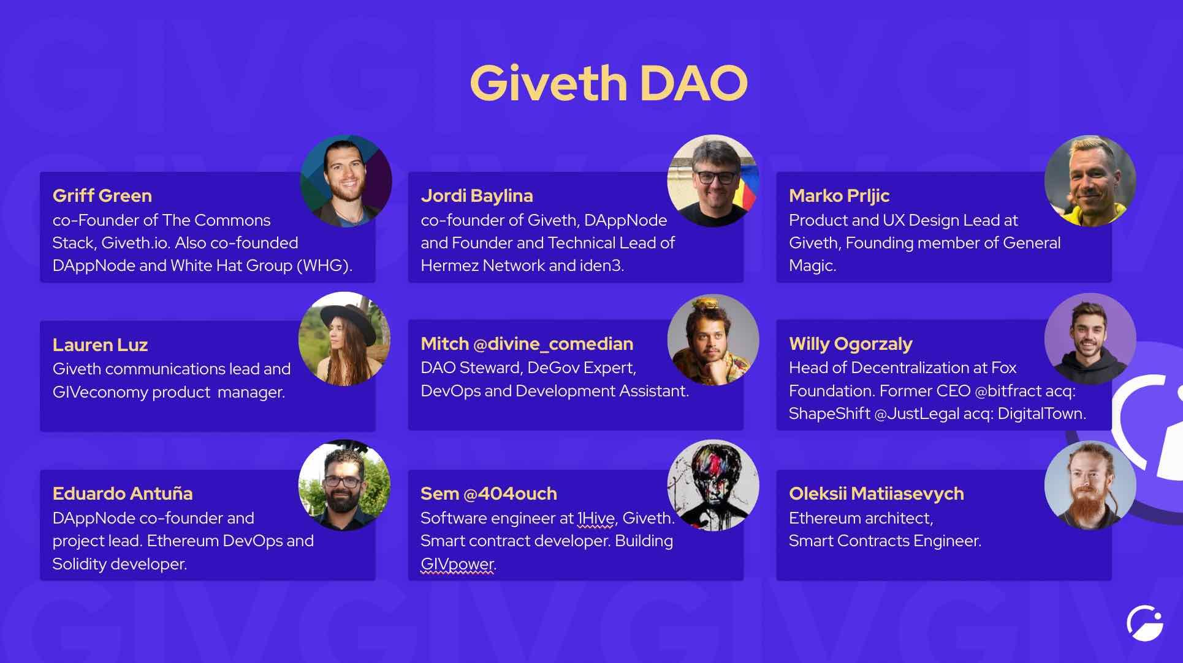

**Valuable Links**

Website: https://giveth.io/

Farming: https://giveth.io/givgarden

Discord: https://discord.gg/Nj9zM9Dq

Twitter: <https://twitter.com/Givethio>

Youtube: [The Biggest Web3 Opportunity That No One Is Talking About](https://www.youtube.com/watch?v=ADSOVkujrI4&ab_channel=ETHDenver)

**Presentations**

Deck: https://bit.ly/3HqkHPQ

DAO presentation: (check Lauren for the metagame/fest presentation)

Willy > Giveth history

**Our Values**

We encourage Decentralization:

Giveth offers innovative open-source solutions built on blockchain technology, which is inherently decentralized.

Giveth is pioneering and experimenting with decentralized governance and communication techniques and supporting their adoption by other communities.

We promote Altruism:

Giveth is an open, non-hierarchical global initiative empowering social, environmental and humanistic impact projects with modern technologies.

Giveth supports many like-minded initiatives that are adding value to the world without necessarily having a direct profit motive.

Giveth is building a self-sustaining giving economy that encourages and rewards altruistic intention.

We believe in the power of Community:

Giveth is an inclusive community united around a common goal.

Giveth is a community-owned platform, building and developing our DApps based on feedback from our members.

Giveth enables trust within communities by increasing transparency and accountability through blockchain technology.

Giveth proactively reaches out to similar initiatives which we see as potential collaborators, as opposed to competitors.

**Our Economies (GIVfarm & GIVbacks)**

Giveth is re-engineering charitable giving by creating an entirely free, open-source platform, built on the Ethereum Blockchain.

RegenFarms is the next generation of ReFi liquidity mining opportunities for DAOs and regens alike. Using our contracts for the GIVfarm and the GIVstream, we are empowering other for-good DAOs to launch liquidity mining incentive programs, “RegenFarms”, with streams of their own. Shapshift and CultDAO are two of our partners benefiting from this.

How everyone benefits from RegenFarms:

* Blockchain4good DAOs > from the ready-made UI, network effects of offering incentives among other Regen Economies and the novel benefits of combining rewards with a streaming service.
* Stakers > from high yields and a wealth of farming opportunities, as well as the opportunity to explore for-good web3 projects.
* Verified projects > from boosted Giveth Matching Pool contributions, courtesy of for-good DAOs.
* The GIVeconomy > from additional liquidity and strengthened partnerships in the Blockchain4Good ecosystem.

The GIVfarm provides 4 liquidity farms - 2 on Mainnet and 2 on Gnosis chain - as well as single asset GIV staking on both chains. APRs range from 200% to 450%.

The GIVstream is another novel concept pioneered by Giveth. When you harvest rewards from the GIVfarm you are not only earning instantly claimable rewards but also receiving and augmenting your own personal continuous stream of GIV.

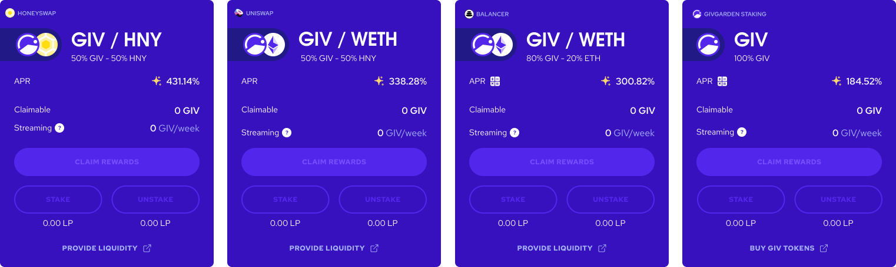

For more details, you can check out the articles on Medium about GIVbacks and GIVeconomy:

https://medium.com/giveth/what-if-giving-gave-back-using-web3-to-evolve-philanthropy-a8500b7636ce

https://medium.com/giveth/welcome-to-the-giveconomy-b3e372da63dd

**> How will your proposal, if activated, benefit BitDAO?**

1) Vision alignment: BitDAO’s vision is open finance and a decentralized tokenized economy. At Giveth this is exactly what we are building. Our intention is to support and reward the funding of public goods by creating open, transparent and free access to the revolutionary funding opportunities available within the Ethereum ecosystem.

2) Up to 8% of the funding round token swap (~4 - 6M worth of $GIV): Holding $GIV diversifies BitDAO treasury and will give access to GIV’s farming streams. We are very much in favor of DAO collaborations and often pursue token swaps with those with whom our vision aligns.

We will not directly sell anything given to us without your consent and we would expect the same from you, it will only be used for liquidity.

We will determine the price of the tokens in advance upon a mutual agreement from both DAOs based on the market prices.

3) DAO-to-DAO collab: Token swap and exposure to our features/protocols. We are working with some of the most well-known and smart engineers in the space who are in the frontiers of tokenomics progression and macroeconomics innovations. We can offer access to plenty of impact DAOs including BrightID, tokenengineering commons, Gitcoin, Panvala, and more.

We are a leader in the publicgoods space and we could help onboard plenty of the projects on BitDAO so they could do crowdfunding onto Giveth. Our goal is to turn public goods orgs into DAOs that they could get invested in.

**> What are the projected outcomes?**

Demonstrate Fiscal Accountability by responsibly provisioning funds and skills toward team structure, conflict resolution, administration, financial transparency, organization of team gatherings and quality assurance. Meet the resource needs of the Giveth community, platform and economy.

Innovate Internal Governance through experimenting with and documenting decentralized governance systems within the Giveth DAO structure (e.g. Sociocracy, Praise, Reputation, Conviction Voting, SourceCred, etc.) that could prove extremely useful for future Decentralized Autonomous Organizations to learn from and implement their own versions.

Collaborate with the Ethereum Ecosystem to develop collaborative tools that generate mutual benefit and success by partnering with and participating in the governance of other mission-aligned organizations such as: Commons Stack, Token Engineering Commons, DAppNode, BrightID, 1Hive, GitCoin and MetaGame.

Create Regenerative Value that nurtures and grows the Giveth Token Economy (GIVeconomy) by empowering individuals toward inclusive decentralized decision making with outcomes that have real impact on the organization and positive change in the world when cascaded through our listed projects.

**> What are the milestones?**

> Specifications and Timeline

Our growth plan:

​​

Angel Vault and path to our stable token (oneGIV) (2022)

To create more liquidity, we are planning to launch $oneGIV and make a protocol owned Giveth Angel Vault. This way we can protect the value of $GIV for GIVbacks, the GIVgarden & all our future ventures. $oneGIV will be used throughout the GIVeconomy.

GIVpower (2022)

$GIV holders will be able to lock their tokens to BOOST projects asking for donations on our platform. The longer they lock, the more the project is BOOSTED and the higher their staking APR.

GIVfi (2023)

Latent donations on the platform will be put into safe defi strategies to earn an interest while waiting for projects to withdraw them. This interest will be used to buy $GIV on secondary markets.

​

​​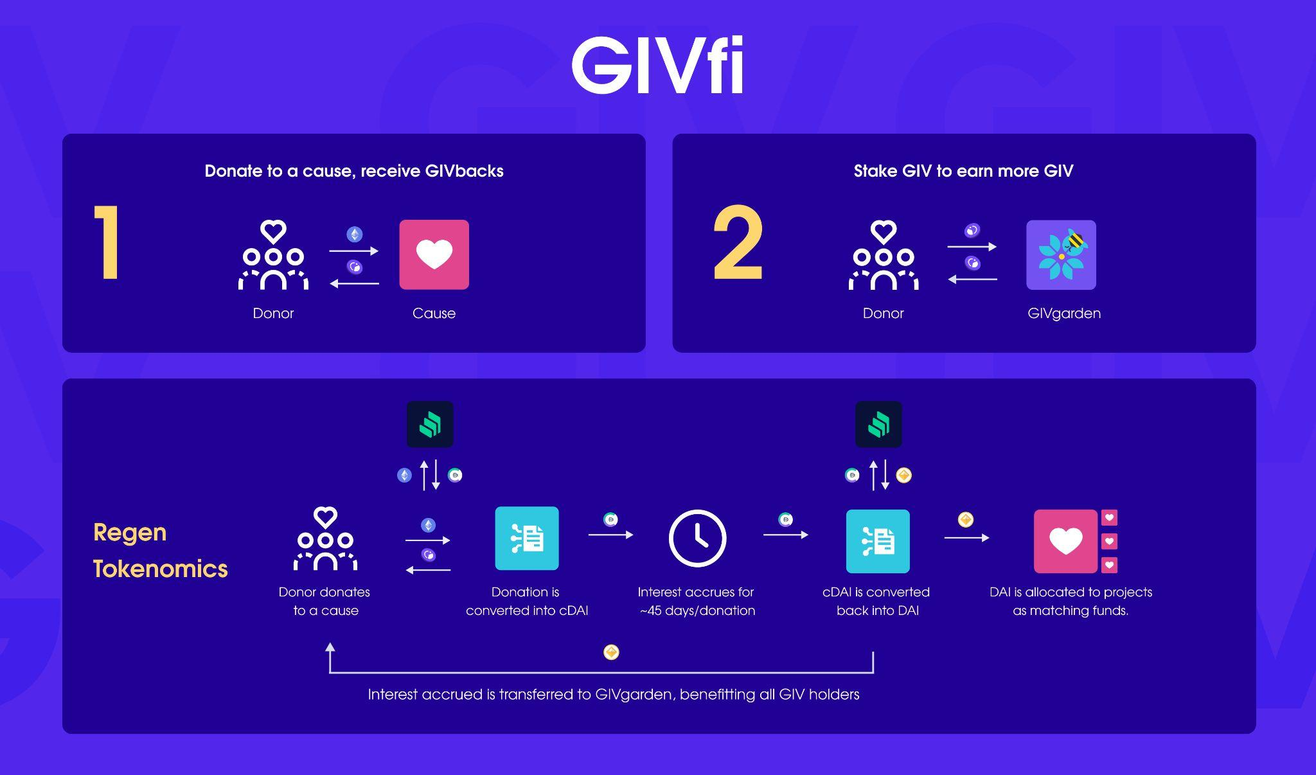

Regen Microeconomies Market powered by $GIV (2024-2025)

With the $GIV staked behind projects via GIVpower, we can enable for-good projects to launch their own microeconomies backed by $GIV in a Bonding Curve. Donors become investors, Volunteers become shareholders with a voice. This is the Future of Giving.

**> How long will it take to complete your proposed changes?**

We estimate 2-3 years based on our project roadmap above to deliver our main vision: Regen Microeconomies using Augmented Bonding Curves model on top of our DApp we want to create continuously funded organizations. (also available [in video format, narrated by Griff Green](https://youtu.be/WJ23oQpooG0?t=694))

> 2. Budget

We are looking to raise 2.5 - 3M (USDC / USDT / DAI or other) by selling our tokens.

We are very flexible in how to structure the round and look forward to hearing the community’s ideas or suggestions for any alternative methods.

We would use the funds to pay our contributors and hire a few full-time senior developers to help us deliver our projects within the timeframe described above.

> 3. Add technical details and/or links to source documentation

https://docs.giveth.io/

> 4. Include any other relevant details on how this proposal will be accomplished

On a final note, we certainly believe our visions with BitDAO align and we would love to extend our knowledge base to a bigger audience. We'd love to share, promote and exchange all the innovations in the token engineering and DAO tooling we are bringing to our community with the rest of the web3.0 pioneers. We truly believe this will be a fruitful collaboration and We hope this proposal would meet a positive response and look forward to partnering up with BitDAO!

~~Doing good feels good, and we hope our alternative economic system will attract more people who want to do good by not just giving but by staying involved.~~ **~~Instead of just simply donating, they get the opportunity to participate in a circular economy that supports the underlying cause.~~** ~~As more people will be encouraged to join the Commons, it incentivizes the people who initialized the curve to do even better, as the initial token holder’s funds will only be unlocked as the community actually does good, and spends the money.~~ **~~By being generous and by participating in good governance they can generate an actual financial return, an income — they create abundance.~~**

> Next Steps? If this proposal is accepted, what are the immediate action items?

1. Preparation of all information about token swap, funding structure and the final offer.

2. Pass a BitDAO governance vote.

3. Increasing the team for faster project development.

4. Building and rolling out updates.

## Review Process

**The BIT Community and delegates might discuss and verify the following before considering proposals.**

#### Personnel

* Is the team credible?

* Are they qualified to do this work?

#### Technical

- Does the proposal make sense technically?

- Does this fit into, or compliment, other projects in the BitDAO ecosystem?

## Temperature Check Poll

[poll type=multiple results=always min=1 max=1 public=true chartType=bar]

# Would you like to see this proposal go to vote?

* Yes

* No

* Needs work

[/poll]